Project Scheduler READ-ME

Time Management is a huge issue for most people. To be productive, we need a way to plan ahead then evaluate later.

I have built a practical schedule tracker application, which allows you to create your schedule – containing date, time, activity, and duration.

There is an evaluation at the end of the schedule of how well the schedule is followed. This is determined by how late an activity is started or how much is completed for an activity.

**Tools needed to run this application:** Python 3.8 Compiler, Database Browser

How to install:

1. Install a database browser (Ex. SQLite) <https://sqlitebrowser.org/blog/first-release-candidate-for-3-12-1/>
2. Open the database file in the database browser.
3. The tables are already created for you. Feel free to modify them to meet your needs.
4. Run scheduletracker.py. A tkinter window should appear on the screen.
5. Fill out the fields for date, time, activity, and duration, then click “Add Record to Database”.
6. Check the schedule table in the database to see if the field is added (may need to refresh the database browser).
7. Do this for the rest of the entries until you have a complete schedule.
8. You can display a schedule for a specific date, which will show on the window.
9. To **edit** a record, type in the record ID and click on ‘Edit Record’ to modify record. **Note:** there are extra fields for evaluating the activity, such as on-time status and completion status. They are only filled out once the activity is over.
10. To **delete** a record, type in the record ID and click on ‘Delete Record’
11. To evaluate how well you followed the schedule based on the extra fields entered for the activities, type in the date. Do not forget to edit and add in the necessary information for the on-time status and completion status. Comments will be displayed in the window, as well as the final score.

For reference,

90-100 Excellent

80-89 Good

70-79 Fair

0-69 Needs Improvement

Sample run-through

1. 2.

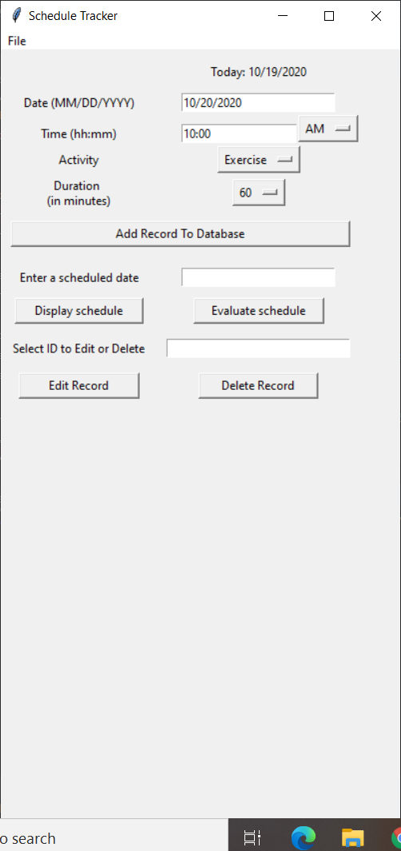 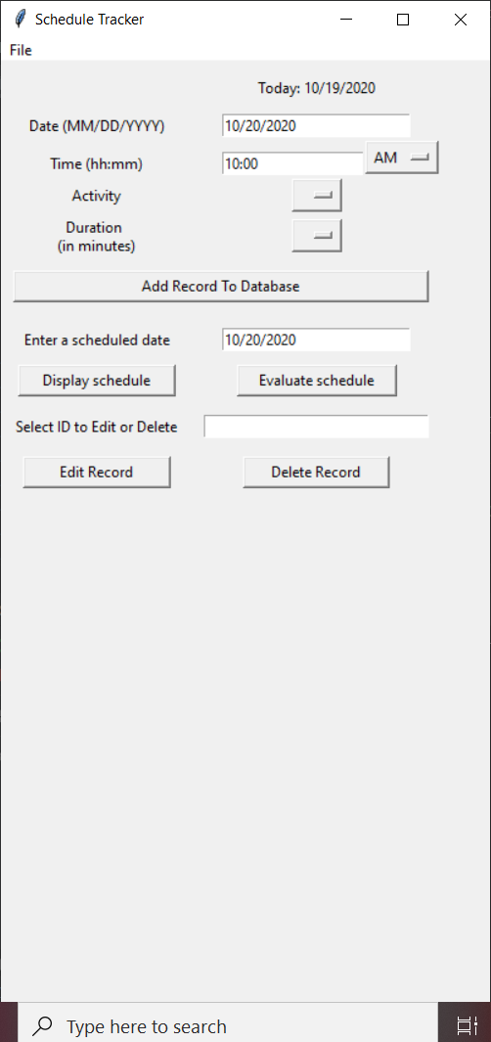

3. 4.

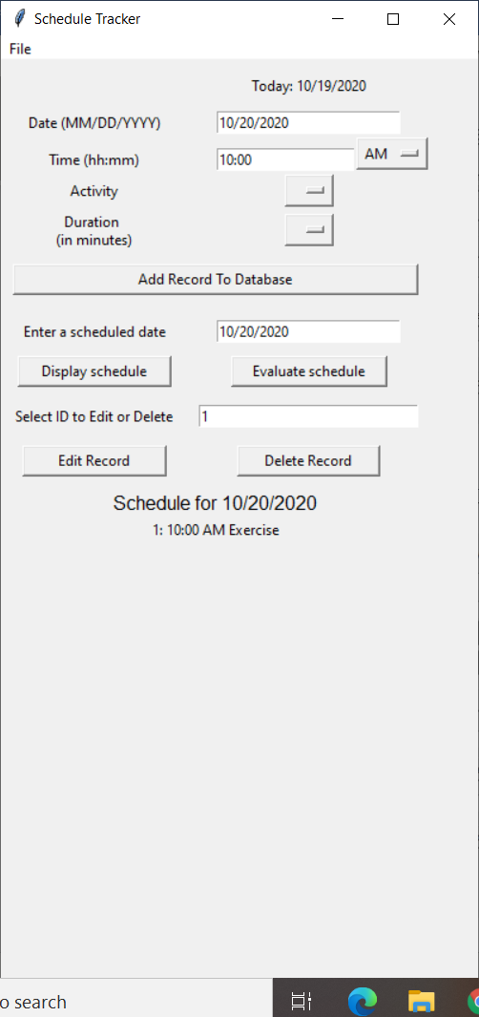 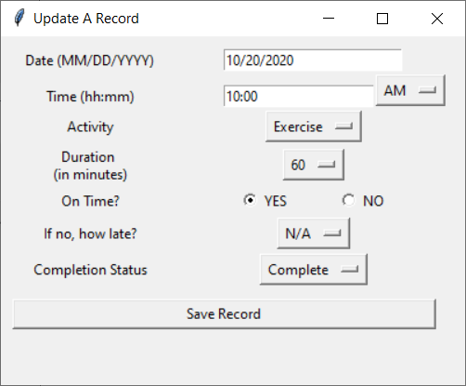

5. 6.

 